S311534

Prabhat Kumar Rauniyar

1. (a)

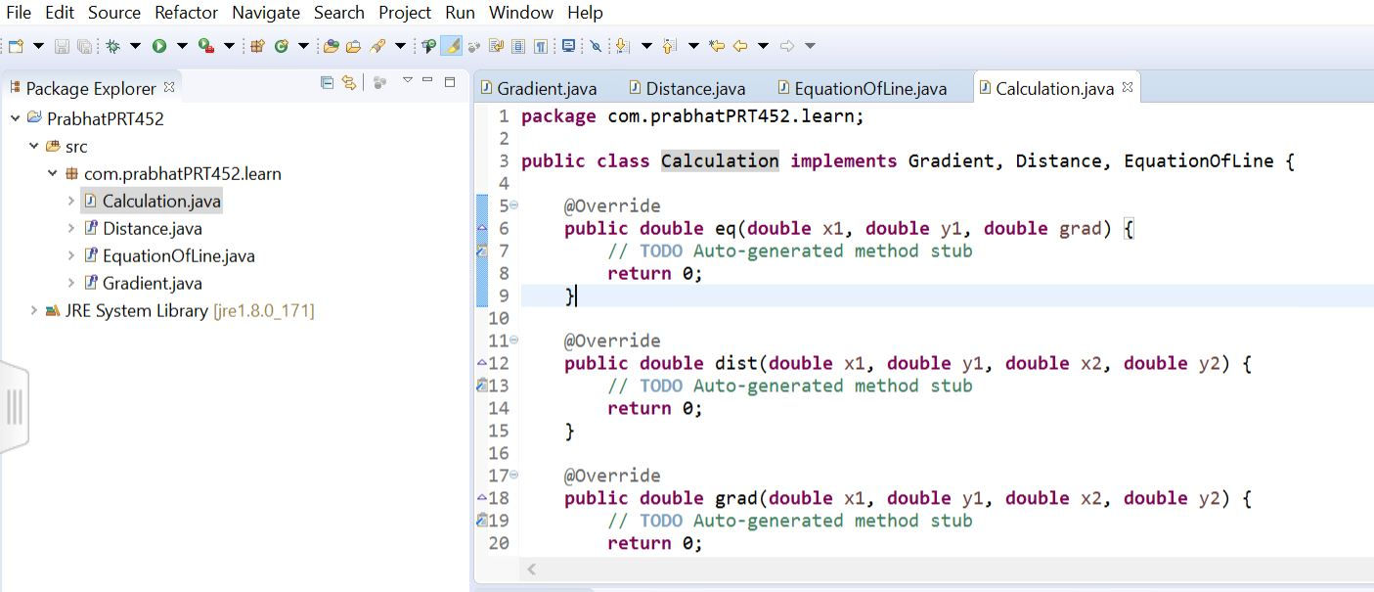

(b)

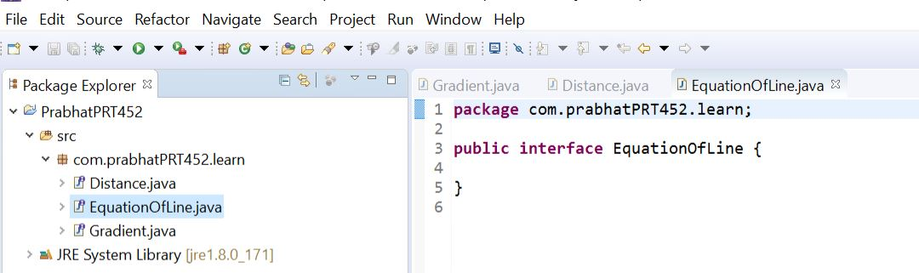

(c)

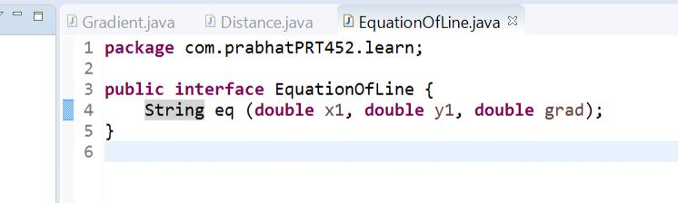

(d)

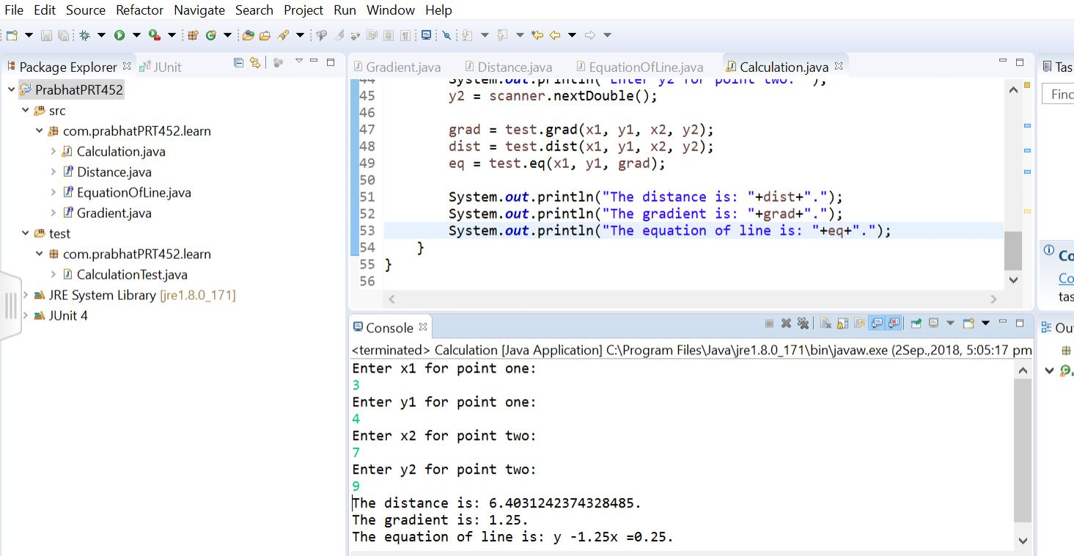

Test Case:

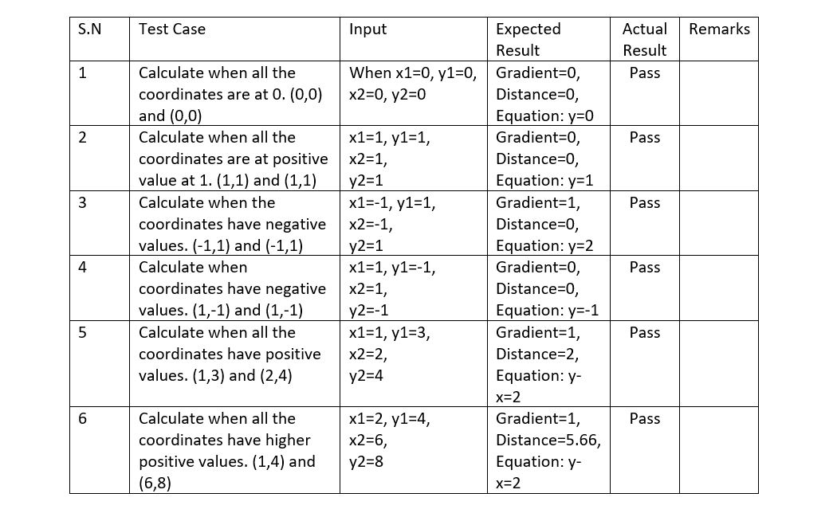

2.

When there will be issue with code , code smell gives an indications to refactoring to solve.

The issue and their solutions are:

1. Duplicated code: This will happen when there’s same code on different place of the code.

Solution: Perform EXTRACT METHOD

1. Long method: It will be hard to understand the code if it’s too long.

Solution: Perform EXTRACT METHOD with query.

1. Large class: It will display many instance variable when a class do many class.

Solution: Perform SUBCLASS or EXTRACT CLASS.

1. Shotgun surgery: It occurs when we make any change on code.

Solution: Perform MOVE METHOD/FIELD

1. Feature Envy: It seems more interested in a class other in the one that it is in.

Solution: Perform EXTRACT METHOD or MOVE METHOD

**Github link:** <https://github.com/s311534/PRT452JUnit/tree/master/PrabhatPRT452>